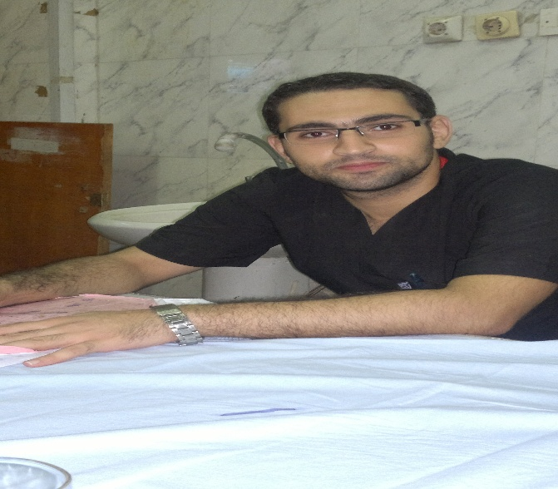

|  |  |
| --- | --- |
| **Personal data** | ***First name*** : Ayman .  ***Middle names*** : Asem Abdelmoghny Ibrahiem.  ***Last name*** : Elqady.  ***Tel: Home*** : +20 88 2154113.  ***Work*** : +20 88 2080435.  ***Cellphone*** : +20 1006186644.  ***Fax*** : +20 88 2333327.  ***Email*** : dr.uro87@gmail.com  ***Date of birth*** : 20/11/1987.  ***Nationality*** : Egyptian.  ***Marital status*** : Married and have 1 child.  ***Military service*** : Achieved.  ***Current Address*** : 4 Sabeel st., behind CID factory, Assiut, Egypt (December 2013 till now)  ***Correspondence*** : Urology and Nephrology Hospital, Assiut University Hospitals, Assiut, Egypt.  ***Current hospital*** : Urology and Nephrology Hospital, Assiut University Hospitals, Assiut, Egypt.  ***Languages*** : - Arabic: Mother tongue.  - English: Very good.  ***Computer skills*** : Competent with most Microsoft Office programs, and some experience with HTML (ICDL certified).  ***Interests*** : Driving cars and internet browsing. |
| **Current position** | Demonstrator of urology, Urology and Nephrology Hospital, Assiut University Hospitals, Assiut, Egypt (4/4/2015 till now). |
| **Positions held** | *House officer* : For full rotational year at Assiut University Hospital (1/3/2011-29/2/2012).  *Urology resident* : Urology Dept., Assiut University Hospital (1/3/2012-4/4/2015)  .  *Demonstrator of urology* : Urology Dept., Assiut University Hospital (4/4/2015 till now).  *Assistant lecturer of urology* : Assiut Urology and Nephrology Hospital, Assiut University Hospitals (29/4/2012 till now). |
| **Qualifications** | *High school diploma (basic education)*: The military high school, Mallawy - Minia , Egypt (2000-2003).  *M.B.B.Ch*: Faculty of medicine, Assiut University (9/2004-9/2010) (Excellent with honor degree). |
| **Professional license** | Egyptian ministry of health full registration .  Egyptian Medical Syndicate. |
| **Memberships** | * Non . |
| **Clinical Experience** | ***During my work as a house officer, as a resident and as a demonstrator , I gained experience in the following activities:***   * Minor surgical maneuvers. * Out-patient and in-patient clinical management. * Management of traumatized patients.   ***Emergency Urology:***   * In the emergency urology unit of my department concerned with the management of cases of obstructive anuria, urinary retention and andrological emergencies as priapism, penile fracture, and acute scrotum.   ***Stones and Endourology:***   * Renal: ESWL, PNL and open surgical stone extraction. * Ureteral: URS and lithotripsy. * Bladder: Cystoscopy, litholapaxy and lithotripsy. * Urethra: Dilatation, VIU and urethroplasty. * Prostate: TURP and open prostatectomy.   ***Uro-oncology:***   * Radical cystectomy (as an assistant). * Radical nephrectomy (as an assistant). * Adrenalectomy for adrenal tumors (as an assistant).   ***Laparoscopic Surgery:***   * Laparoscopic nephrectomy and radical nephrectomy. * Laparoscopic renal cyst deroofing. * Laparoscopic pyeloplasty. * Laparoscopic orchiolysis and orchiopexy. * Laparoscopic high ligation of varicocele.   ***Female Urology:***   * Anterior colporrhaphy for cystocele repair. * Tension-free vaginal tape procedure (T.V.T) Trans-obturator Tape (T.O.T). * Vesico-vaginal fistula repair (both abdominal and vaginal approaches). * Urethral diverticulectomy.   ***Neuro-urology:***   * Botulinum toxin A (Botox) intra-detrusor injections. * Bladder augmentation (as an assistant).   ***Investigative Urology:***   * Abdominal Ultrasonography. * Scrotal Ultrasonography and Doppler. |
| **Graduate, post graduate training:** | 2004-2010: Graduate studies; Faculty of medicine, Assiut University.  2011-2012: House officer at Assiut University Hospital for a full rotational year.  2012-2015: Urology resident at Assiut University Hospital.  2015- till now : Urology demonstrator, Faculty of Medicine, Assiut University. |
| **Courses, conferences and training programs attended** | * 2012 till now: Attendance and active participation in all conferences and seminars held by the Assiut Urology and Nephrology Hospital, Assiut University Hospitals * Attended Uro-Assiut 2015 “Updates and Debates” at Marsa Alam, Egypt on 3-5 Feb. 2015. |
| **Teaching activities** | Supervising house officers since March, 2012.  Supervising the work of residents since March, 2015 till now. |
| **Research activities** | Correlation between MSCT data , X-ray data of urinary stones with X-ray diffraction analysis data, supervised by Professor Mohammed Essameldien Osman , Professor Hassan Abdellatief Abolella , and Assistant Professor Mohammed Mahmoud Gadelmoula ; Urology and Nephrology Hospital, Assiut University Hospitals. |
| **Public activities** | Participating in the volunteering medical campaign at Abo Teig , Assiut, Egypt. |
| **Referees and references** | * Assiut University was inaugurated in 1957 to encourage research, education and community services in Upper Egypt. It is located in Assiut City, which is 375 Km south of Cairo; the capital. The university comprises sixteen faculties and two higher institutions. PO Code No. 71515, Egypt. [http://www.aun.edu.eg](http://www.aun.edu.eg/). * Assiut University Hospital is one of the biggest University Hospitals in Egypt. It is the core referral center for the whole Upper Egypt that serves about twenty million people. The hospital contains about 3000 beds. 1634 medical and 6580 paramedical staff serve in this hospital.  [http://www.aun.edu.eg/hospitals/.](%20http://www.aun.edu.eg/hospitals/.%20) * Assiut Urology and Nephrology Hospital was established since 2012. Actually, it is the continuation of urology department, which is serving patients since 1970s. Our newly established hospital contains 200 beds for patients, in addition to intensive care unit and renal transplantation unit (under construction). Our out-patient clinic serves more than 200 patients with more than 60 operations performed per the week * Hisham Mokhtar Hammouda; Professor of urology, and Chairman of Urology and Nephrology Hospital, Assiut University Hospitals.   *Correspondence*: Urology and Nephrology Hospital, Assiut University Hospitals, Assiut, Egypt.  Tel: +2088 2080435 Fax: +2088 2333327. |